2019 IDHA ANNUAL CONFERENCE EVENT LOCATION DETAILS

Hotel Details

Fort Harrison State Park Inn/Hotel
- Call 877-563-4371 and Identify Ft. Harrison State Park or to go directly to the Inn/Hotel and call
317-638-6000, Option 1 to make room reservations. Provide Code: IDHA
- Let the Inn/Hotel know you are attending the IDHA Annual Conference to be included in the IDHA block of rooms and to get the conference rate of $119.99 per each room in our block.

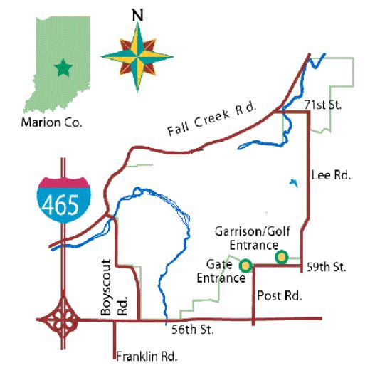
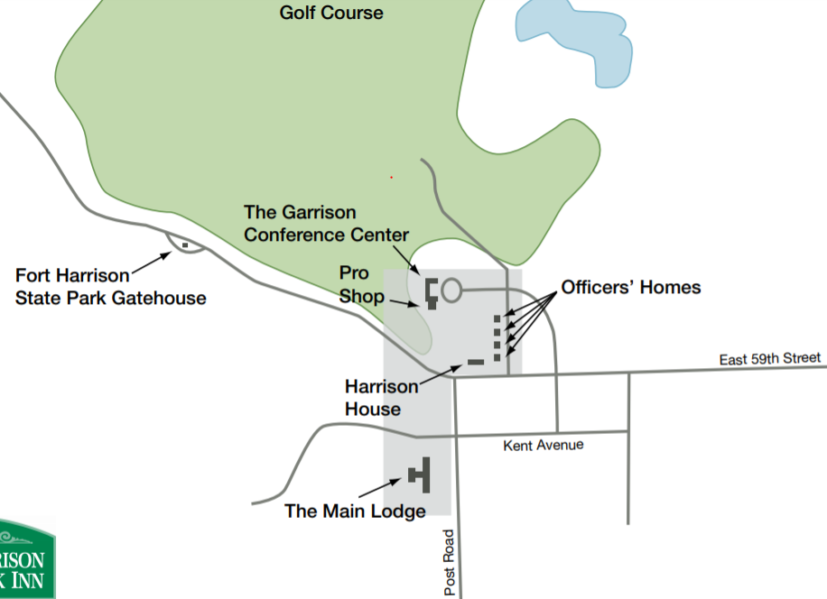
Local Map: Ft. Harrison State Park Conference/Lodging Campus:

Driving Directions
- From the NORTH:
Take Interstate 65 South, US 31 South, or Interstate 69 South toward Indianapolis to Interstate 465, head east, and then 465 will curve south. Follow 465 to the 56th Street Exit (Exit 40) and turn left (East) onto 56th Street. Turn left (North) on Post Road and follow until the road ends at 59th Street, turn right (East) onto 59th Street.*
- From the SOUTH:
Take Interstate 65 North, Interstate 69 North/SR 37 North, or US 421 North toward Indianapolis to Interstate 465 and head east (turn right). Follow 465 as it heads north and take the 56th Street Exit (Exit 40) and turn right (East) onto 56th Street. Turn left (North) on Post Road and follow until the road ends at 59th Street, turn right (East) onto 59th Street.*
- From the EAST:
Take Interstate 70 West toward Indianapolis to the Post Road Exit (Exit 91). Follow the right fork of the exit and head North on Post Road and follow until the road ends at 59th Street, turn right (East) onto 59th Street.*
- From the WEST (Indianapolis International Airport):
Follow the Airport Expressway to Interstate 70 East toward Indianapolis to Interstate 465 North. Follow 465 North to the 56th Street Exit (Exit 40) and turn right (East) onto 56th Street. Turn left (North) on Post Road and follow until the road ends at 59th Street, turn right (East) onto 59th Street.*

*Once you turn onto 59th Street, the entrance drive to the golf course, conference center, and lodging is on the North (left-hand) side of the road about one and a half blocks East of Post Road.

