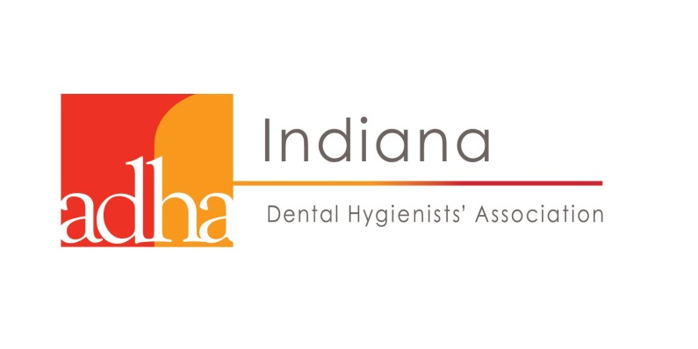

2018 IDHA ANNUAL CONFERENCE

Verification of Attendance Certificate

Ethics: Borders and Boundaries

Hour(s) Spent in the CE course: 3

Format (check one):
- Live Lecture/Presentation
- Live Workshop/Hands-on Participation Course
- Live Webinar

Presented by: Amanda Apple, LDH, BGS
Heather L. Taylor, MPH, LDH

Saturday, November 3; 1:30pm–4:30pm

Fort Harrison Garrison Conference Center
6002 N. Post Road
Indianapolis, IN 46216

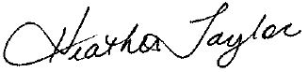

IDHA President Signature Attendee Signature License Number

The Indiana Dental Hygienists’ Association (IDHA) is a state organization that operates as an affiliated entity under the approval of the American Dental Hygienists’ Association.

The IDHA does not approve or endorse individual courses or instructors, nor does it imply acceptance of credit hours by the board of dentistry. It is the responsibility of each attendee to verify the credit hour requirements of his/her licensing or regulatory agency. Attendees should retain this certificate for their records.

This continuing education (CE) activity has been planned and implemented in accordance with IDHA Bylaws and policies.

Concerns or complaints about a CE provider may be directed to the provider or to the IDHA Central Office.

